SonarQube Quality Gate Configurations

We can have any one of the Quality Gates out of the below mentioned Gates.

1. Java CIA (Confidentiality Integrity Availability) Quality Gate
2. Excellent / Good Quality Gate
3. Minimum Quality Gate
4. Recommended Quality Gate

Find below the detailed Quality Gate Conditions that need to be configured in SonarQube .

1. 1. Java CIA (Confidentiality Integrity Availability) Quality Gate

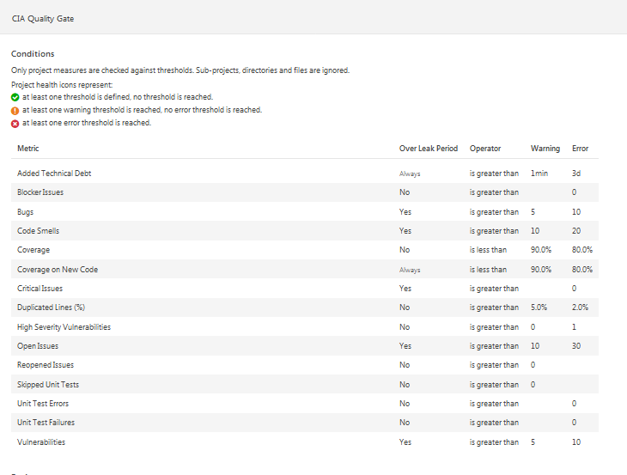

1. Excellent / Good Quality Gate

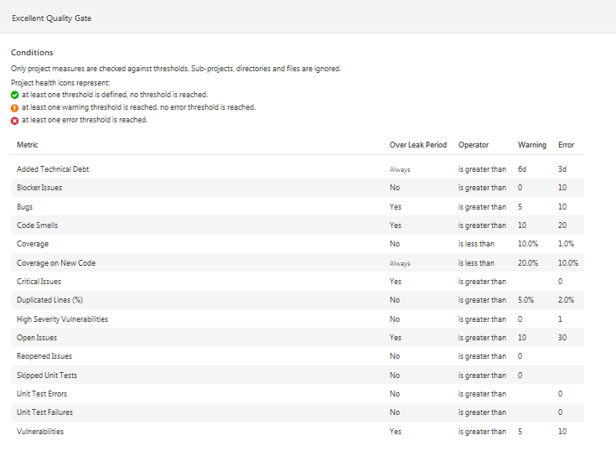

1. Minimum Quality Gate

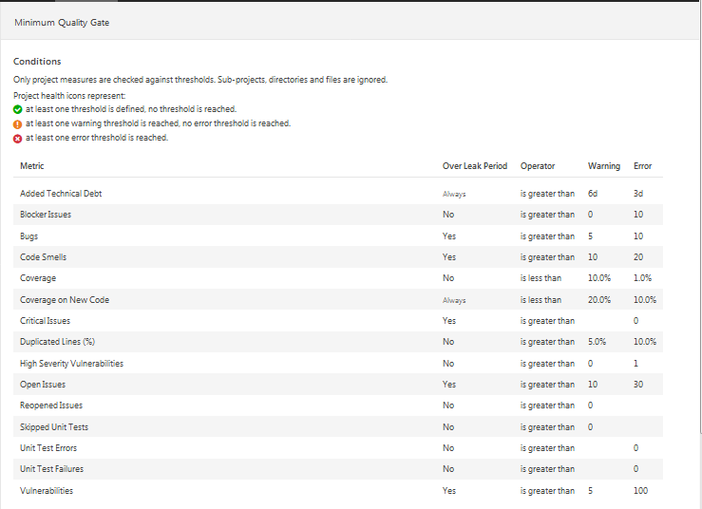

1. Recommended Quality Gate

